# Preparing for R-Cade

The goal of this write-up is to make the transition from CoinOpsX (SaUCEy Build) to the new R-Cade platform.

Advantages of R-Cade over CoinOpsX:

***Need write-up justifying this process***

1. Download the CoinOpsX builds from the following:

CoinOpsX build: <https://archive.org/details/coinops-x-arcade-version-5-is-still-alive-saucey-edition-full-fixed-build>

CoinOpsX Vertical build: <https://archive.org/details/coinops-x-vertical-wopr-sa-uce-edition>

1. Create a folder structure on your PC:

/roms

/roms/mame

/roms/mame/_CoinOpsX

/roms/mame/_CoinOpsX/Arcade

/roms/mame/_CoinOpsX/3 Player Build

/roms/mame/_CoinOpsX/4 Player Build

/roms/mame/_CoinOpsX/Lightgun Build

You can do the same for the CoinOpsX Vertical build:

/roms

/roms/mame

/roms/mame/_CoinOpsX - Vertical

/roms/mame/_CoinOpsX – Vertical/Arcade

1. Download and Install 7z
2. Go to location of CoinOpsX SaUCEy 5.0. Start with the 3 Player Build UCEs by highlighting them all and extracting to individual folders:

NOTE:

You will receive errors when extracting. Disregard. We’re only trying to get the rom files from the UCEs.

1. Do a search for “*.zip” (without quotes). Highlight all the zipped files. Copy them over to the /roms/mame/_CoinOpsX/3 Player Build directory created earlier.

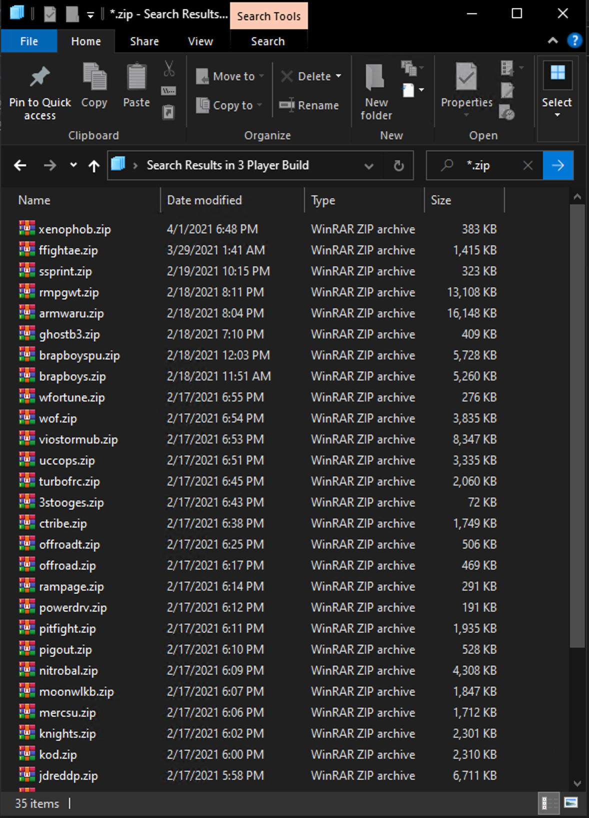

Repeat the same steps for 4 Player Build, Arcade, and Lightgun Build.

1. Copy all the zipped files into a folder named “'CoinOpsX_Combined” (without quotes)

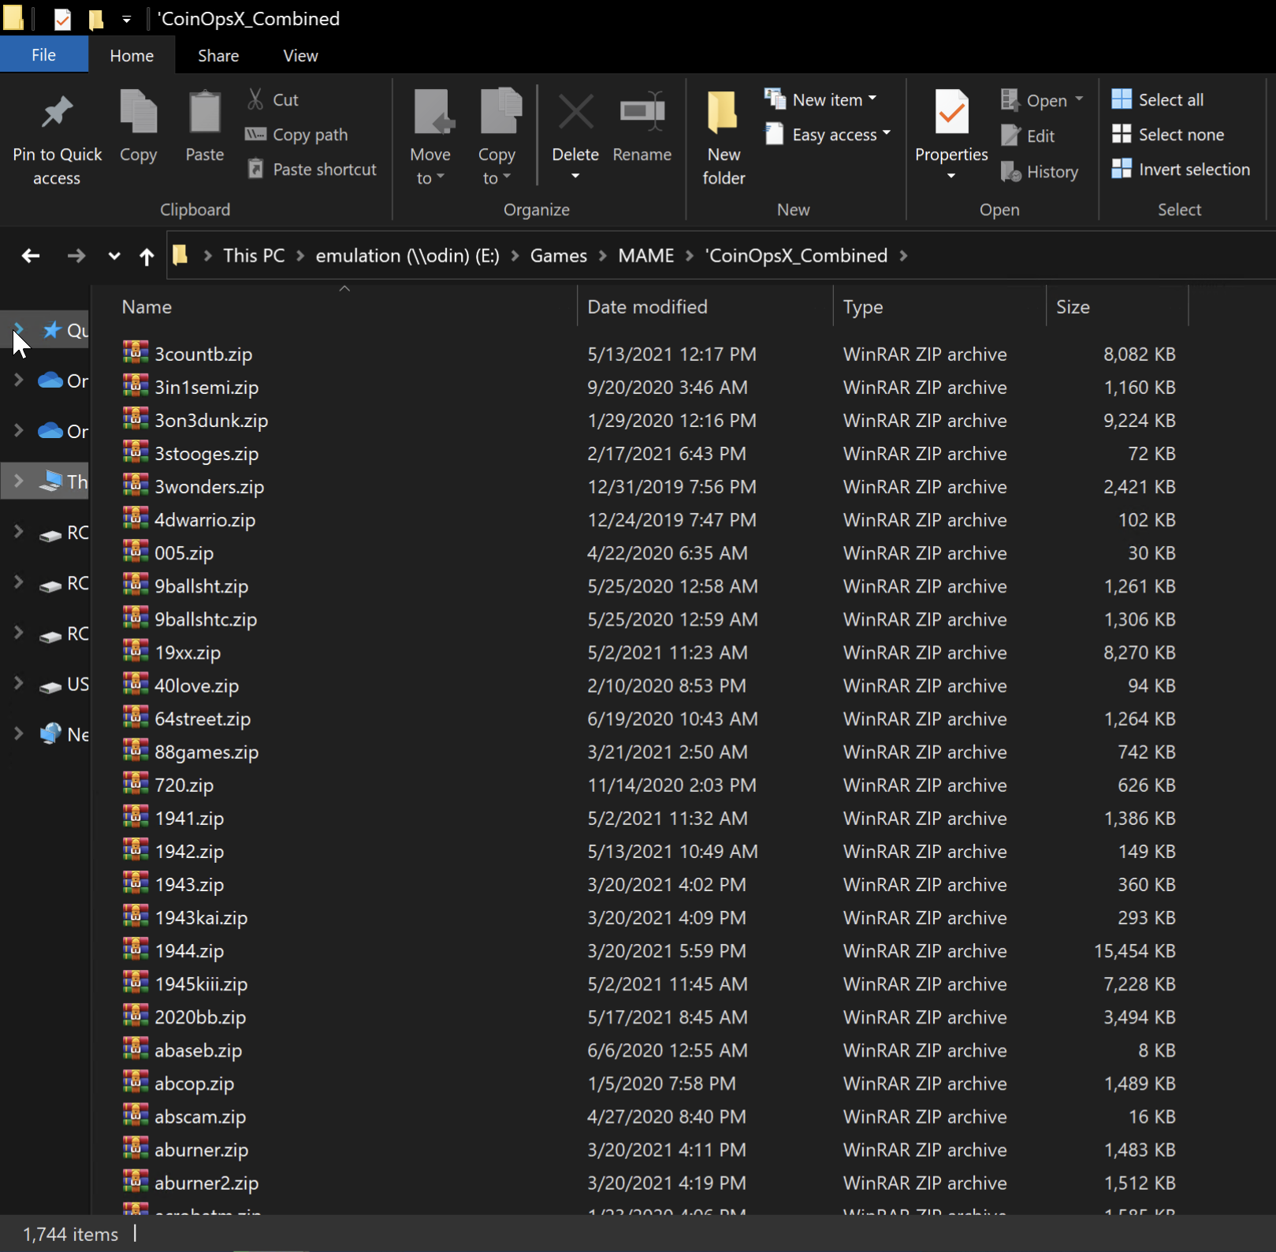

1. Copy the 'CoinOpsX_Combined directory to \\IPOFALU\share\roms\mame